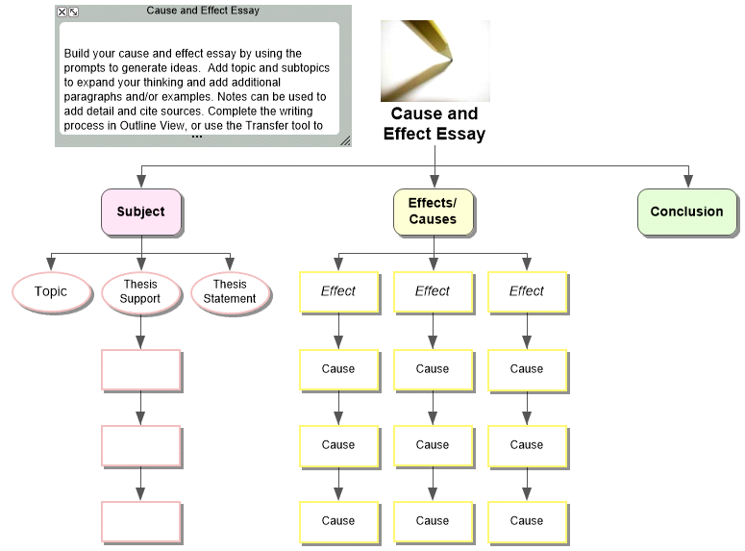

Cause and Effect Essay
Build your cause and effect essay by using the prompts to generate ideas. Add topic and subtopics to expand your thinking and add additional paragraphs and/or examples. Notes can be used to add detail and cite sources. Complete the writing process in Outline View, or use the Transfer tool to continue the writing process in a word processor.
I. Subject
A. Topic
Choose a topic for which you are able to make a cause (reason) and effect (result) connection.
B. Thesis Statement
Write a general statement that shows the relationships between the cause and the effect.
C. Thesis Support
Which 3 points will explain or prove your thesis statement?
1.
2.
3.
II. Effects/Causes
Break down the larger topic into smaller pieces, supporting each effect with causes.
A. Effect
What is an effect of the problem, event or issue?
1. Cause
What causes explain why the effect happened?
2. Cause
3. Cause
B. Effect
1. Cause
2. Cause
3. Cause
C. Effect
1. Cause
2. Cause
3. Cause
III. Conclusion
How will you sum-up the relationship between the causes and effects presented?

